The Secret Garden Day Nursery and Pre-School
The Secret Garden Day Nursery & Pre-School
3 Barton Villas
Dawlish
EX7 9QJ
01626 862862
Email- sophie.secretgarden@hotmail.co.uk
March 2021
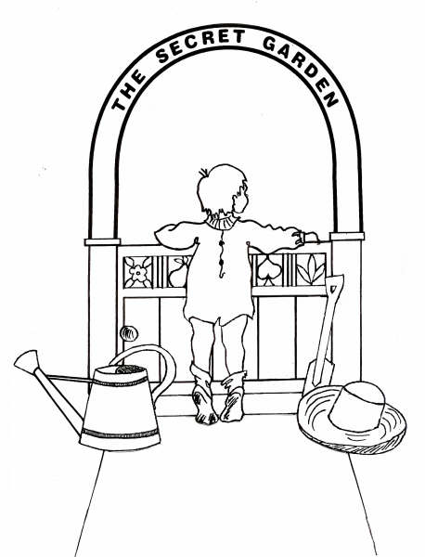Dear parents/ carers
As we reach the one-year anniversary of being forced to close our doors due to COVID-19, I would like to thank you all so much for staying with us, supporting us, and continuing to put your trust in us to keep your children safe during this pandemic. We truly love what we do and feel privileged to care, educate and have so much fun with your children on a daily basis.
We continue to follow all advice and guidance along with putting our own health and safety measures in place for all in contact with the setting. As your aware schools reopened to all children on Monday 8th March, this did not affect us as we continued to open to all our families as normal. From 22nd March our staff team will have access to the Lateral Flow Devices (LFD) for them to test themselves twice a week to identify positive cases more quickly and to break the chains of transmissions. I will keep you updated as soon as I have any further information.
Below I have set out some reminders regarding policies and procedures relating to COVID-19 and how they should be implemented by all involved with the setting.

- We will continue to close the setting at 5:45pm for staff to clean the setting thoroughly ready for the next day. If you are running late please ensure you contact the setting to notify us and a late fee charge will be added to your next invoice at the discretion of the manager/ Proprietor.

- We are doing all we possibly can to ensure safety for all in contact with the setting and are following necessary guidance and updates (sometimes with only hours to prepare) to continue operating as normal as we possibly can do. I understand there maybe times where you become frustrated or unhappy with a decision we must make, but please can I remind you to continue showing staff the respect they deserve and be mindful of the language used in front of children, and other parents/ carers.

- Drop off and collection continues to remain the same, with staff from your child’s room bubble meeting you and your child/ ren at the main door or the side door. We do all we possibly can to get to the door to greet you as soon as we can, please can I ask for you to remain patient with us.
- Upon drop off and collection you must ensure you are wearing a mask unless you are exempt. If you are exempt, please can I ask you email me to let me know so I can inform staff. If you fail to wear a mask when dropping off or collecting your child, you will be given one of our disposable masks at a charge of £1 which will be added to your invoice. There is a sign visible on our baby room window stating to knock on the window for a mask to be given to you while in the queue.

- Please can you ensure you are respectful of our social distancing measures- giving other parents/ carers space and time to drop off/ collect, avoid close contact with staff and use the one-way system we have in place. Please can you also ensure you have said your goodbyes (kiss and cuddle) to your child/ ren prior to them coming over to a member of staff to avoid any unnecessary close contact with you and the staff member.
- Only 1 parent/ carer should be present when dropping off or collecting your child/ ren. It should be prompt and anything you wish to discuss further can be done via telephone, zoom or email. Please avoid hanging around to chat to other parent/ carers within our car park area.

- Please use the hand sanitiser provided upon drop off and collection. There are also gloves available if you would like to use them.

- Please only buzz the intercom system when the parent/ carer in front of you has either moved over to the side drop off zone, or if the parent/ carer in front of you has dropped their child off with a member of staff.

- All children are to bring in a water bottle which is clearly labelled.

- A reasonable size bag with a change of clothes, nappies, wipes etc We ask you consider the size of your child’s bag as we have an awful lot of bags to store and do our best to keep them separated from one another. They are sprayed and wiped over upon entering the setting.

- If your child is having an immunisation or their flu nasal spray, they are not to attend nursery for a minimum of 24 hours in case it causes a reaction. If your child has been taken to A & E or they have been admitted to hospital, they will be unable to attend the setting for a minimum of 24 hours also. This will also need recorded on the relevant forms we have at the nursery and Pre-school.

- If your child shows any signs or symptoms of coronavirus, they will be unable to attend nursery until they have had the Coronavirus test. The results must be emailed to myself for evidence as I must inform Devon county council of how many have been tested within the setting. If your child tests negative, they may return to the setting if they are well enough in themselves, with no high temperature and they have not had any medication for 24 hours.

- If your child/ ren is not going to attend the setting due to illness or simply having a family day, please can we ask you contact the setting via telephone or email at your earliest convenience.

- Medication- Any child who is on antibiotics will be unable to attend the setting for a minimum of 48 hours after their first dose. This is in case they have a reaction to the medication and to give them time to restore back to full health. We will be able to administer the medication at the setting when they return, and a medication form will need completing prior to the child attending.

- We reserve the right to send your child home if we feel they are not 100% themselves. We must continue to be extremely cautious during these times to keep everyone safe and well. Please keep in mind the time it may take you to collect your child if they are unwell, and if there is someone else on your contact list who might be able to collect them sooner. This is to minimise spread of infection and avoid the child having to be isolated with a staff member in full PPE for a long period of time.

- If you are travelling abroad please could you email me to let me know where, when and how long you will be away for. We will continue following Government guidance on isolation periods after travelling, however we do reserve the right to make our own decisions upon anyone travelling and returning to the setting.

- If your child/ ren are attending another setting or childminder, please ensure we are informed as we will need to risk assess with their other provider to continue providing the safest possible environment for all. Those children who are claiming funding with us and another provider must inform us of their child’s sessions with the other provider so we can complete a conflict buster with them.

- If you have a new contact number or wish to make any changes to your child’s permission forms please let us know at your earliest convenience.

Unless otherwise changed by myself, The Department for Education or Public Health England, we will continue to follow the current policies and procedures stated in the most recent update letter.
Nursery News
Each room within the setting will continue to send out updates which relate directly to what your child/ ren is currently focusing on, any celebrations coming up, the current learning topic, home learning links and any other relevant information they feel necessary to share. These will be sent via email so please ensure we have your most up to date email and check your junk mail as we would not want anyone to miss out.
Government Funding and Nursery Fees
If your child is eligible for the Government Early Years funding next term, please ensure you complete the paperwork in time for your requests to be met. Paperwork can be sent via email or a paper copy, please inform us of your preference. If you are applying for the 30 hours funding, please follow the link and necessary steps to see if your child is eligible- https://www.gov.uk/apply-30-hours-free-childcare
Over the last two years there has not been an increase in the settings fees, regardless of increasing costs, limited access to funding, COVID-19 hitting us extremely hard and yet we have continued to keep going as best as we possibly can do and continue providing the highest quality, care, and education we can for your little ones. We will be reviewing our fees and a separate letter will be sent out with all necessary information regarding the increase, help with childcare costs and how our Government Early years funding works.
As we reach nearly the one-year mark I cannot help but look back on how far we have come, and I could not be prouder of the staff team I have working alongside me. They have gone above and beyond to provide care, education, and routine to all our families little ones, old and new. With limited PPE and fears for their own families, they have come in everyday with a smile on their face and full of love and enthusiasm ready to provide some normality for our children.
If you would like to discuss anything or find yourselves struggling during this lockdown, please do not hesitate to contact us and reach out. We are here to support you all and are in this together.
Take care and stay safe.
Kind Regards
Sophie Penaligon
Nursery and Pre-School Manager

